Cairo University **SEM - team 7**

Faculty of Engineering

Computer Engineering Department

CMP2020 for semester

Introduction to Database Systems

TripSync

***ER diagram Report***

Team Number: 7

Team Members:

|  |  |  |
| --- | --- | --- |
| Name | Sec number | BN |
| Esraa Hassan Rajaa Elfatairy | 1 | 10 |
| Gehad Nasser abo saria | 1 | 18 |
| Hazem Ahmed Mohamed Emam | 1 | 19 |
| Mohamed Abdelaziem Sayed | 2 | 57 |

Contant Info:

|  |  |
| --- | --- |
| Name | Email |
| Esraa Hassan Rajaa Elfatairy | [esraa.elfatairy04@eng-st.cu.edu.eg](mailto:esraa.elfatairy04@eng-st.cu.edu.eg) |
| Gehad Nasser abo saria | [Gehad.Abdullatif04@eng-st.cu.edu.eg](mailto:Gehad.Abdullatif04@eng-st.cu.edu.eg) |
| Hazem Ahmed Mohamed Emam | [Hazem.Emam04@eng-st.cu.edu.eg](mailto:Hazem.Emam04@eng-st.cu.edu.eg) |
| Mohamed Abdelaziem | [mohamed.bakry04@eng-st.cu.edu.eg](mailto:mohamed.bakry04@eng-st.cu.edu.eg) |

Table of Contents

Problem definition: 3

**Users:** 4

• Traveler 4

• Travel Agency 4

• Admin 4

**Entity Types:** 5

**Relationships:** 6

**1.Message → User:** 6

**2.User → Profile:** 6

**3.User → Blogs:** 6

**4.Admin → Policies:** 7

**5.Admin → Rewards:** 7

**6.Admin → Q&A:** 7

**7.Travel Agency → Q&A:** 7

**8.Travel Agency → Trips:** 7

**9.Travel Agency → Promote Trips:** 7

**10.Travelers → Tickets:** 7

**11.Tavel Agencies → Tickets:** 7

**12.Traveler → Reports:** 7

**13.Traveler → Review:** 7

**14.Traveler → Notification:** 7

**15.Traveler → Rewards:** 7

**ER Diagram:** 8

# Problem definition:

TripSync addresses the major challenges faced by travelers and travel agencies in the modern travel industry. Currently, travelers deal with disjointed systems that fail to integrate essential features like trip booking, itinerary management, feedback, and communication. This fragmentation creates a poor user experience, making it difficult for travelers to stay organized, book trips efficiently, or engage with service providers effectively.

For travel agencies, the lack of a centralized platform limits their ability to attract and retain customers. Agencies struggle to showcase their services, manage bookings, and foster loyalty. In a competitive industry, this reduces their ability to build meaningful relationships with travelers or create repeat business opportunities.

Another significant issue is the absence of a structured rewards system. Most platforms do not provide travelers with incentives to engage consistently. Without a way to earn and redeem points for bookings, reviews, or referrals, travelers lack motivation to return, leading to reduced customer retention for both the platform and the agencies.

Communication barriers also contribute to inefficiencies. Travelers often face delays in receiving information or responses from travel agencies, while agencies lack the tools to engage users effectively. This disconnect is compounded by a lack of personalized notifications, trip suggestions, and feedback systems, further diminishing user satisfaction.

Trip Sync aims to solve these problems by creating a centralized travel management platform that bridges the gap between travelers and travel agencies. It incorporates a robust loyalty and rewards system, enabling travelers to earn points for booking trips, writing reviews, and engaging with the platform. These points can be redeemed for discounts, exclusive deals, or upgrades, incentivizing frequent use and fostering long-term loyalty.

For travel agencies, Trip Sync offers tools to promote services, manage bookings, and encourage repeat business through targeted promotions and user feedback. Administrators are equipped with oversight features to monitor platform quality, resolve issues, and ensure a seamless experience for all users. By addressing these challenges, Trip Sync creates a unified and engaging ecosystem that transforms how travelers and agencies interact in the digital travel landscape.

# **Users:**

## Traveler

The Traveler is an individual who uses the TripSync platform to browse and book trips offered by various travel agencies. They can create an account, manage their profile, write blogs, and track their travel history. Travelers can also provide feedback on their experiences by leaving reviews for agencies, and if necessary, report any issues with agencies, can give reviews for agencies they have dealt with and the trips they’ve completed. They are incentivized to stay engaged with a loyalty points system and have the option to report issues with travel agencies or their trips. Travelers can also communicate through messages within the platform and receive notifications.

## Travel Agency

The Travel Agency user type is designed for businesses that organize and manage travel experiences for travelers. Agencies can set up detailed trip listings, share travel blogs, and offer promotions to enhance the business. The platform also participate in a rewards system to build customer loyalty. Through these tools, agencies can reach a wider audience and tailor their services to meet traveler preferences. Additionally, they have messaging capabilities for direct communication with travelers and if necessary, report any issues with travelers and add their own Questions&Answers section to provide information about their agency.

## Admin

Admins play a crucial role in maintaining the integrity and quality of the platform. They have full control over user accounts and trip listings, enabling them to edit or delete content as needed based on user behavior or complaints. Admins can create additional admin accounts, manage app policies, and push notifications to keep users informed. Admins also manage rewards giving them comprehensive control over the platform’s ecosystem and add Questions&Answers section to provide information about the platform.

# **Entity Types:**

**1. User**

Represents individuals interacting with the system. This includes anyone accessing the platform, such as travelers, admins, and travel agencies. It manages general information and accounts for all users.

**2. Admin**

Admins oversee the platform, ensuring smooth operations and managing content. They handle creating and enforcing policies, responding to user queries via Q&A, resolving issues, and monitoring user activity. Admins also manage the rewards system, travel agency relationships, and platform integrity, acting as the backbone of the system's functionality.

**3. Travelers**

A specific type of user who engages with the platform to buy tickets, write reviews, earn rewards, and interact with travel agencies. Travelers can set preferences, browse travel packages, and earn loyalty points for booking trips. This entity connects directly to other entities like Trips, Booking, Review, and Rewards, forming the primary customer base of the system.

**4. Travel Agency**

Represents the businesses that provide travel packages and services. Travel agencies manage trip listings, handle promotions, and communicate with users. Each agency can manage its reputation by see their reviews and improving service offerings. They are a critical part of the ecosystem, linking Trips, Promotions, and Reviews.

**5. Trips**

Represents the travel packages or experiences offered by agencies. This entity includes information about destinations, durations, pricing, and available seats, forming the core of the system.

**6. Blogs**

Provides a platform for users, especially travelers, to share travel experiences, tips, and insights. Blogs foster a sense of community among users and help inspire others to explore new destinations. This entity promotes user engagement and adds value to the platform.

**7. Policies**

Represents the rules, guidelines, and terms governing platform usage, trip bookings, and agency operations. Policies are created and managed by admins, ensuring compliance, transparency, and a clear understanding of rights and responsibilities.

**8. Q&A**

Represents a database of questions and answers, facilitating user inquiries and support. This entity helps improve user engagement and provides quick assistance. Can be done with either the admin for the whole website or with the travel agency.

**9. Rewards**

Represents a system to incentivize travelers for their activity on the platform, such as buy tickets or leaving reviews. Rewards can be taken by a certain number of points for each reward.

**10. Tickets**

Represents the physical or digital proof of a traveler's booking for a trip. This entity manages ticket details, including trip, traveler, and payment status, to ensure proper tracking and organization.

**11. Notification**

Represents system-generated messages or updates sent to users about bookings, promotions, reminders, or other important activities.

**12. Profile**

Represents detailed user information, allowing users to personalize their experience on the platform.

# **Relationships:**

## **1.Message → User:**

**Sender/Receiver:** Messages are exchanged between users (travellers or admins or travel agencies). Each message has a sender and a receiver, enabling two-way communication for inquiries or requests.

## **2.User → Profile:**

**Has:** Each user has one profile containing their personal details and admin cannot have one.

## **3.User → Blogs:**

**Writes:** Users can create and write multiple blogs to share their travel experiences and tips.

## **4.Admin → Policies:**

**Put:** Admins create and manage platform policies to regulate platform usage and ensure compliance.

## **5.Admin → Rewards:**

**Put:** Admins manage the rewards system, defining how users earn and redeem points for trips.

## **6.Admin → Q&A:**

**Make:** Admins handle Q&A sections to provide answers to traveller queries and improve platform support.

## **7.Travel Agency → Q&A:**

**Make:** Travel Agencies handle Q&A section to provide answers to traveller queries about the agency and their trips.

## **8.Travel Agency → Trips:**

**Makes:** Travel agencies create and offer multiple trips for travellers to explore. Each trip is associated with one agency.

## **9.Travel Agency → Promote Trips:**

**Promote:** Travel agencies can run promotional offers on trips, defining discounts (e.g., percentages) and expiration dates.

## **10.Travelers → Tickets:**

**Buy:** Travelers purchase multiple tickets, each associated with a specific trip.

## **11.Tavel Agencies → Tickets:**

**make:** Tickets are issued for trips by the travel agency that do the trip. This connects the trip details to the ticket information.

## **12.Traveler → Reports:**

**Reports:** Travelers can report issues or concerns related to trips, linking reports to specific travellers.

## **13.Traveler → Review:**

**Reviews:** Travelers write reviews for trips or agencies, helping other users make informed decisions.

## **14.Traveler → Notification:**

**Receives:** Travelers receive notifications about Trips that they bought a ticket for, rewards, or other platform updates.

## **15.Traveler → Rewards:**

**Gets:** Travelers can redeem points into some rewards then they can get it.

# **ER Diagram:**

**Without Attributes:**

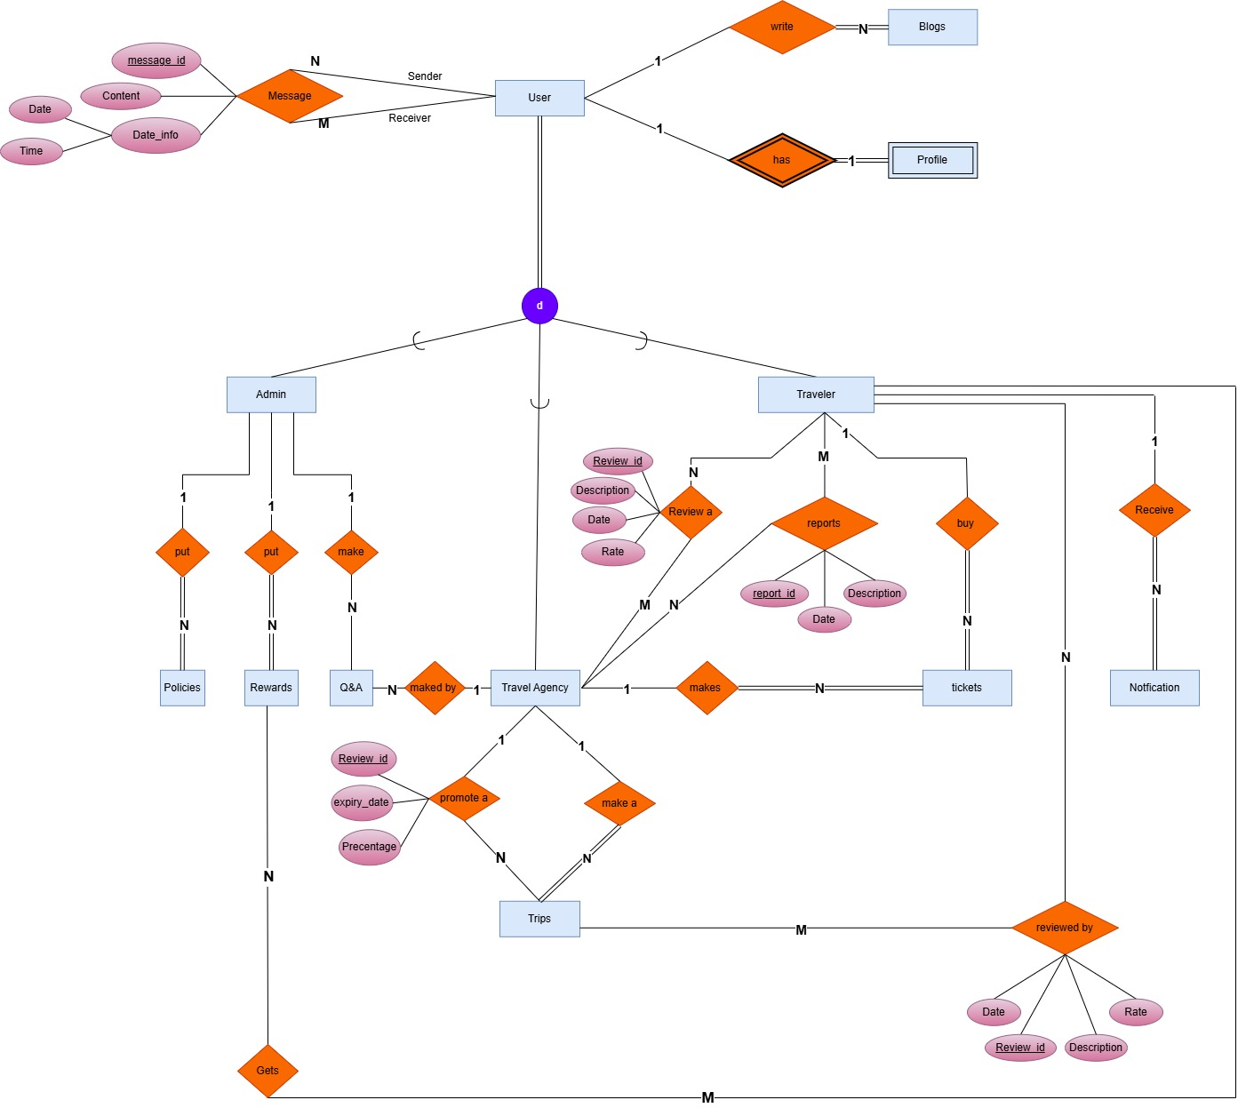

**With attributes:**

